ASSIGNMENT - 8.2

2303A510G1
Batch : 30

Task Description
Task 1 – Test-Driven Development for Even/Odd Number Validator • Use AI tools to first generate test cases for a function is_even(n) and then implement the function so that it satisfies all generated tests.
Requirements:
- Input must be an integer
- Handle zero, negative numbers, and large integers Example Test Scenarios:
is_even(2) → True is_even(7) → False is_even(0) → True is_even(-4) → True is_even(9) → False Expected Output -1
- A correctly implemented is_even() function that passes all AI- generated test cases

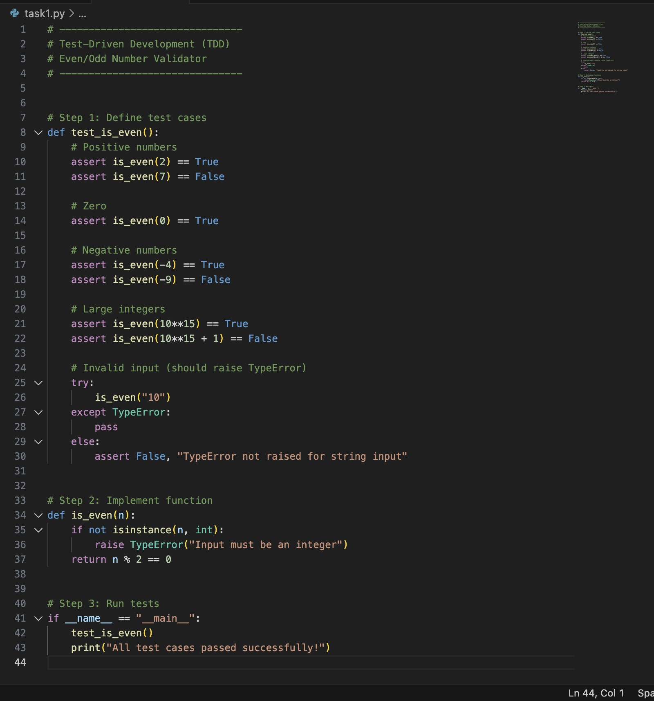

Output:
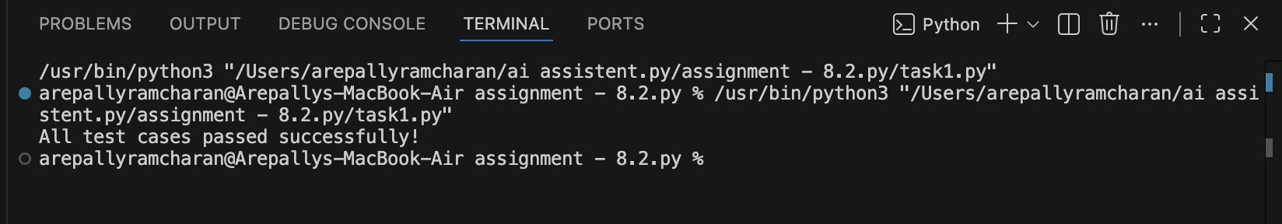
Observation:
The Test-Driven Development (TDD) approach ensures that test cases are written before implementing the function, improving code reliability.

Writing assert-based test cases helped verify the correctness of the is_even(n) function for positive, negative, zero, and large integer inputs.

Input validation using isinstance() ensures that only integer values are accepted, and a TypeError is raised for invalid inputs.

The modulus operator (n % 2 == 0) correctly determines even numbers, including negative integers.

Running all test cases successfully confirms that the function satisfies functional requirements and handles edge cases properly.

Task Description
Task 2 – Test-Driven Development for String Case Converter
- Ask AI to generate test cases for two functions:
- to_uppercase(text)
- to_lowercase(text)
Requirements:
- Handle empty strings
- Handle mixed-case input
- Handle invalid inputs such as numbers or None Example Test Scenarios:
to_uppercase("ai coding") → "AI CODING" to_lowercase("TEST") → "test" to_uppercase("") → ""
to_lowercase(None) → Error or safe handling
Expected Output -2
- Two string conversion functions that pass all AI-generated test cases with safe input handling.

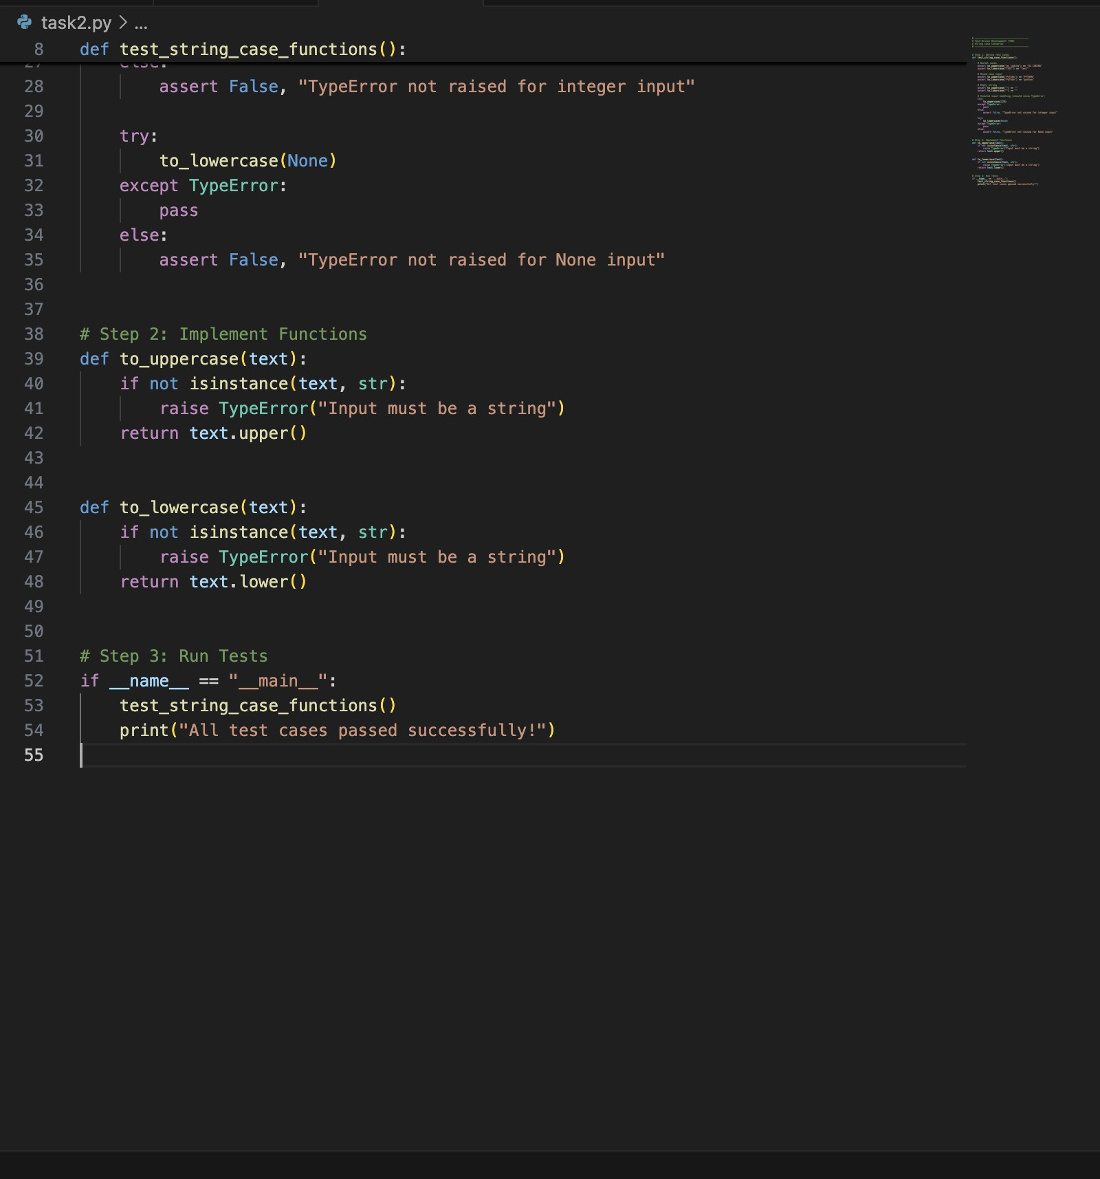

Output:
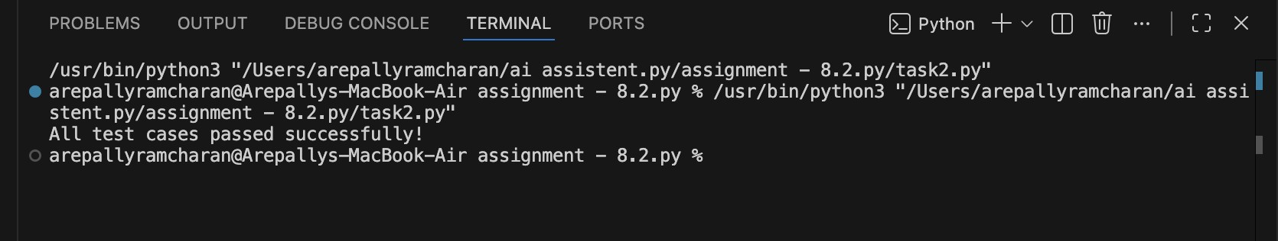
Observation:
  - The Test-Driven Development (TDD) approach ensures that test cases are written before implementing the string conversion functions.

  - The .upper() and .lower() built-in string methods correctly convert text while preserving non-alphabet characters.

  - Edge cases such as empty strings are handled safely without errors.

  - Input validation using isinstance(text, str) ensures that invalid inputs like integers or None raise a TypeError.

  - Successful execution of all test cases confirms that both functions meet functional and safety requirements.

Task Description
Task 3 – Test-Driven Development for List Sum Calculator
- Use AI to generate test cases for a function sum_list(numbers) that calculates the sum of list elements.
Requirements:
- Handle empty lists
- Handle negative numbers
- Ignore or safely handle non-numeric values Example Test Scenarios: sum_list([1, 2, 3]) → 6 sum_list([]) → 0 sum_list([-1, 5, -4]) → 0 sum_list([2, "a", 3]) → 5
Expected Output 3
- A robust list-sum function validated using AI-generated test cases.

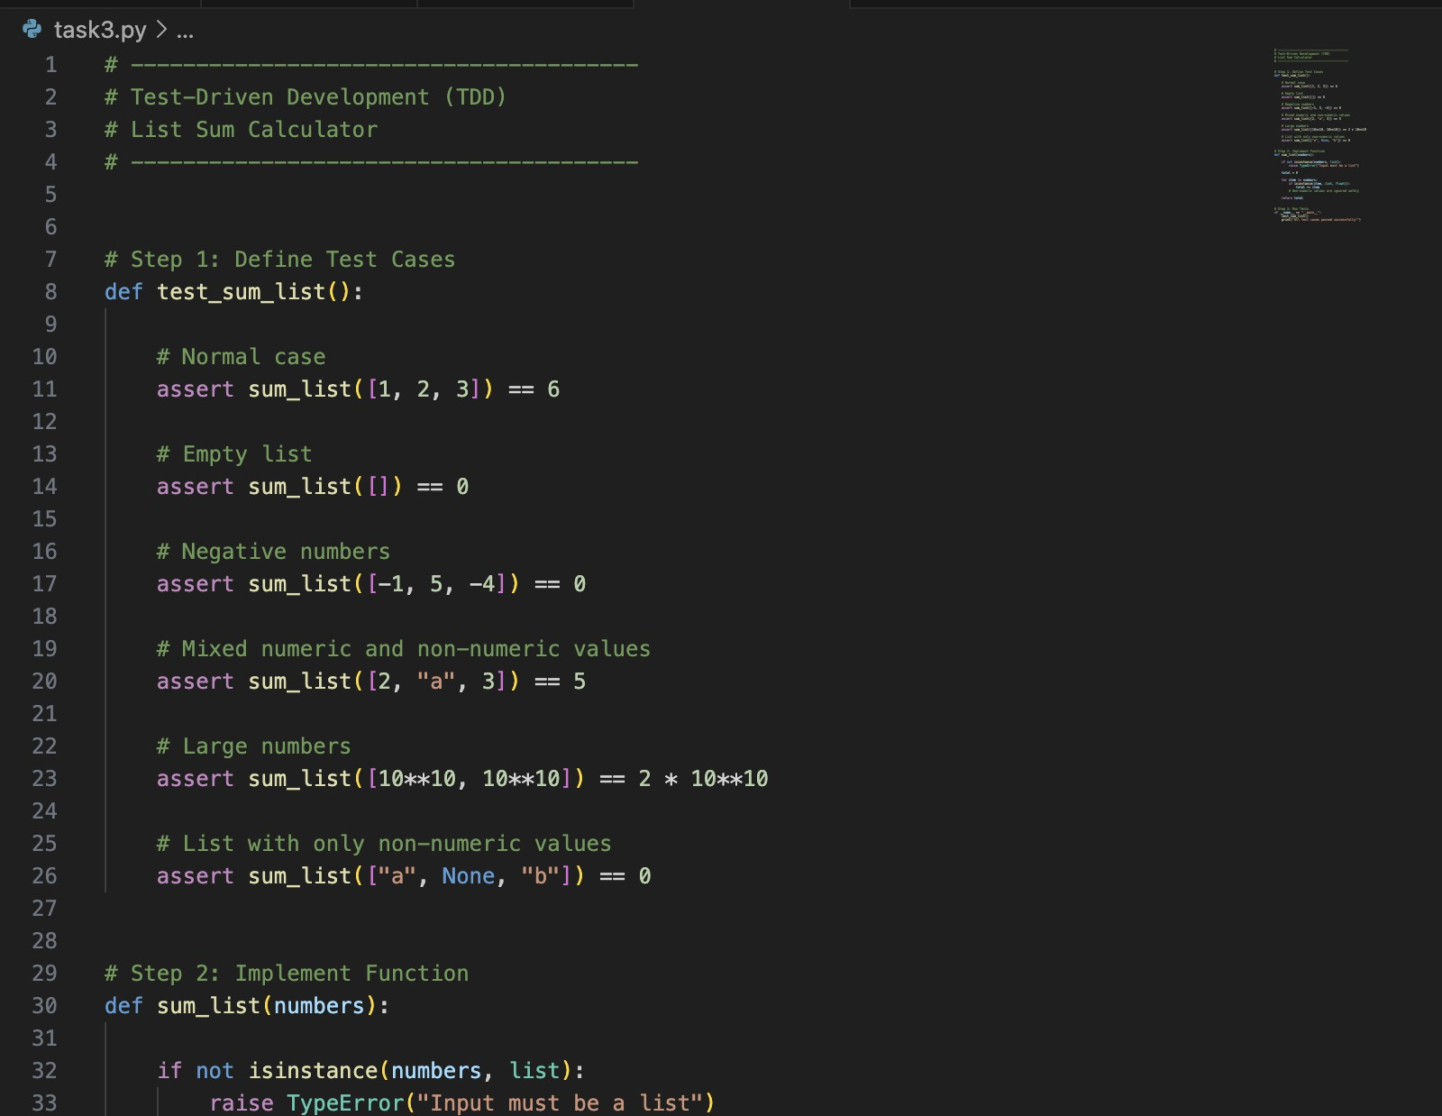

Output:

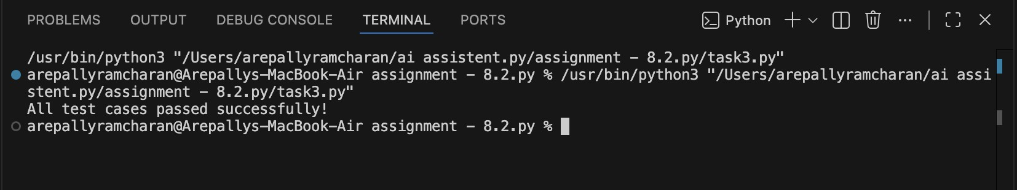
Observation:

  - Test-Driven Development (TDD) ensures that test cases are written before implementing the sum_list() function.

  - The function correctly handles empty lists by returning 0, preventing runtime errors.

  - Negative numbers are properly included in the summation logic.

  - Non-numeric values such as strings and None are safely ignored, improving robustness.

  - Input validation ensures that only list inputs are accepted, raising a TypeError for invalid input types.

Task Description
Task 4 – Test Cases for Student Result Class
- Generate test cases for a StudentResult class with the following methods: • add_marks(mark)
- calculate_average()
- get_result()
Requirements:
- Marks must be between 0 and 100
- Average ≥ 40 → Pass, otherwise Fail
Example Test Scenarios:
Marks: [60, 70, 80] → Average: 70 → Result: Pass
Marks: [30, 35, 40] → Average: 35 → Result: Fail
Marks: [-10] → Error
Expected Output -4
- A fully functional StudentResult class that passes all AI- generated test

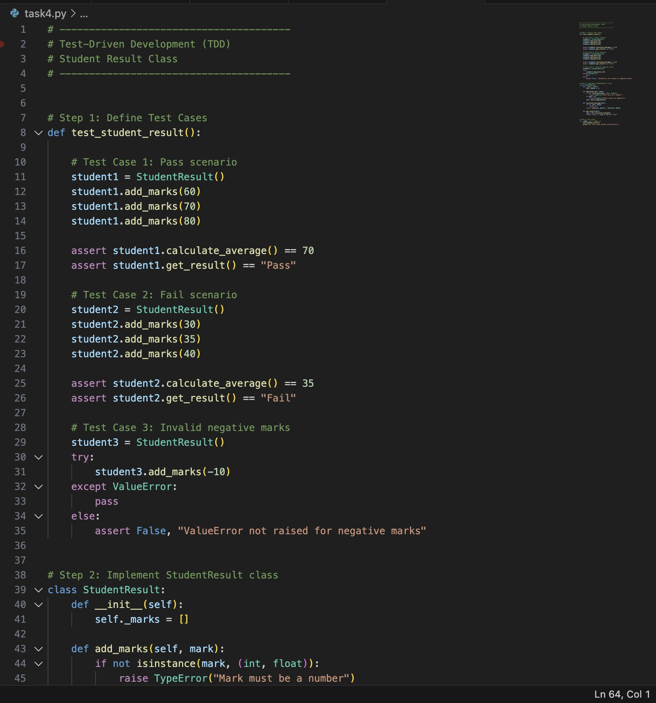

Output:

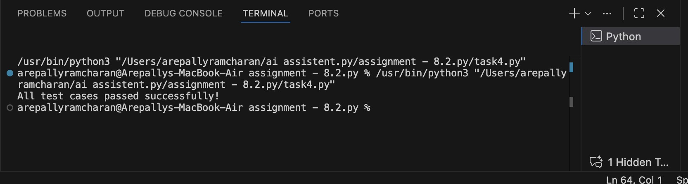

Observation:

  - The Test-Driven Development (TDD) approach ensures all class methods are validated before final implementation.

  - The add_marks() method enforces strict validation, allowing only marks between 0 and 100.

  - The calculate_average() method safely handles empty mark lists by returning 0.

  - The get_result() method correctly determines Pass or Fail based on the average threshold of 40.

  - Exception handling improves robustness by preventing invalid data from being stored.

Task Description
Task 5 – Test-Driven Development for Username Validator Requirements:
- Minimum length: 5 characters
- No spaces allowed
- Only alphanumeric characters
Example Test Scenarios:
is_valid_username("user01") → True is_valid_username("ai") → False is_valid_username("user name") → False is_valid_username("user@123") → False
Expected Output 5
A username validation function that passes all AI-generated test cases.

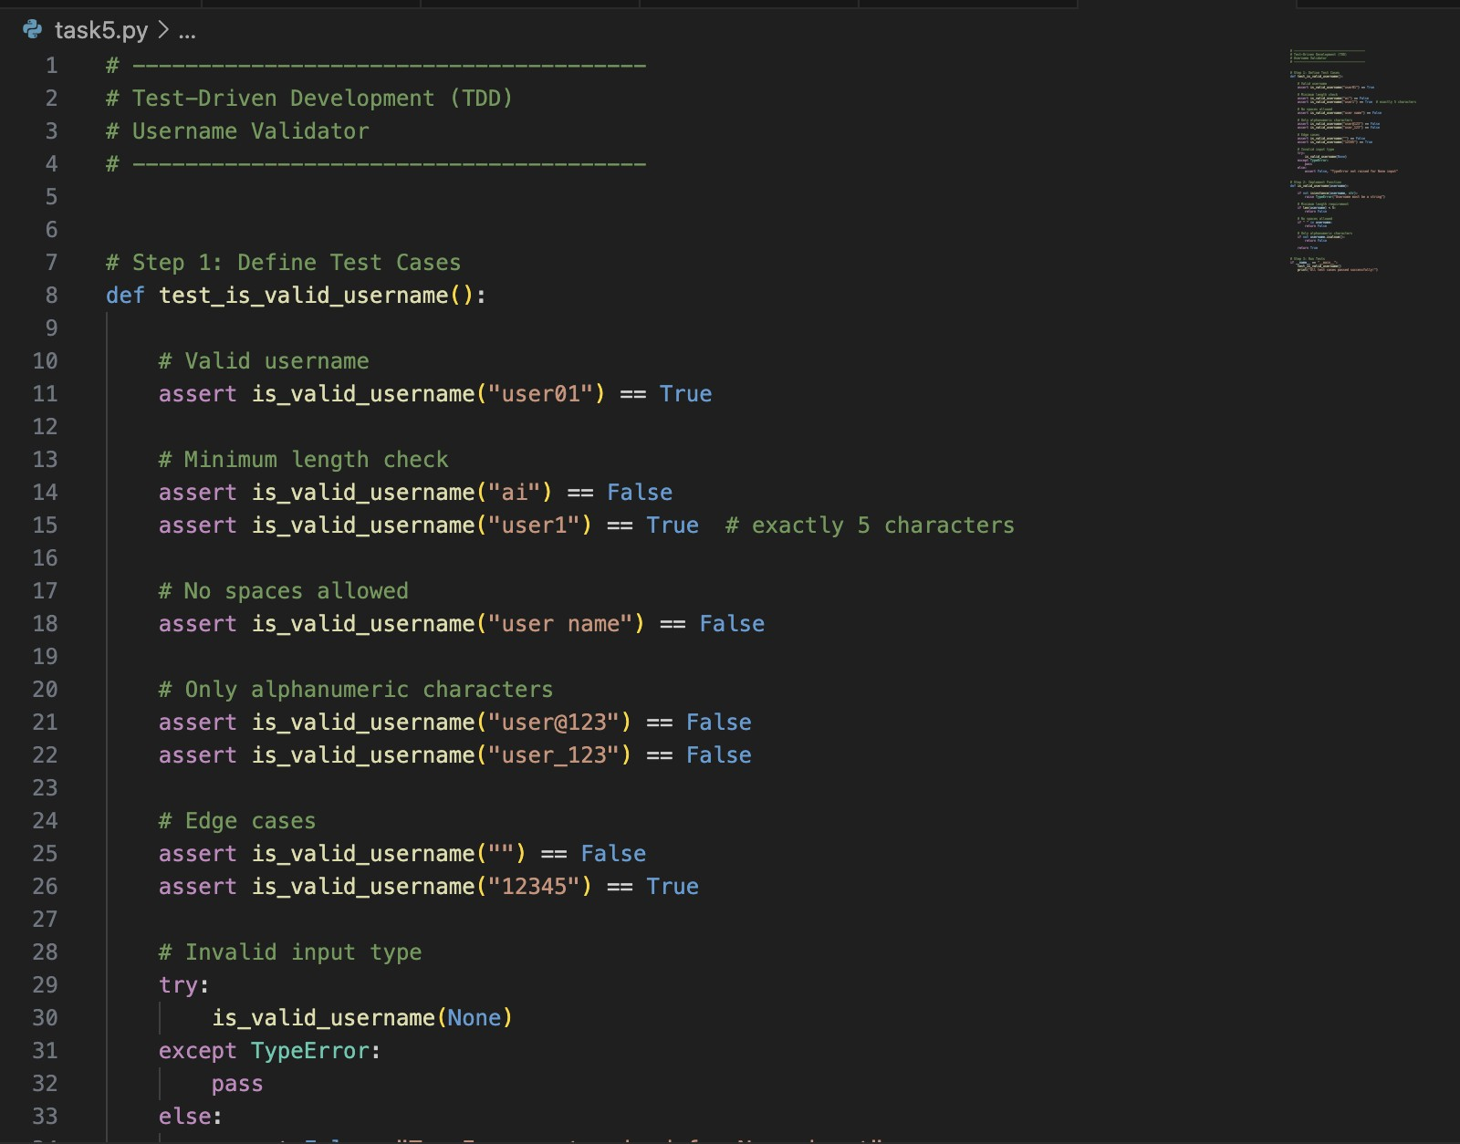

Output:

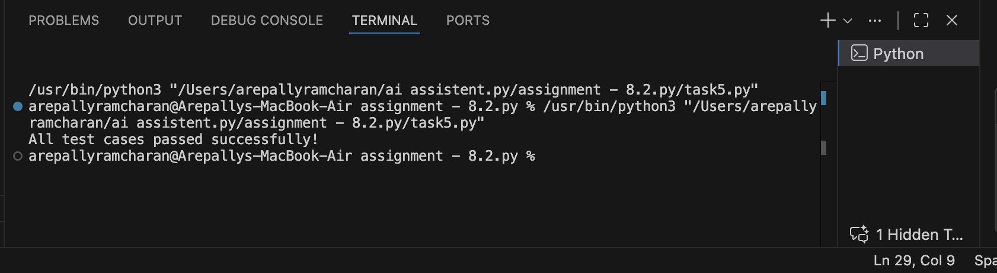

Observation:

- Test-Driven Development (TDD) ensures validation rules are clearly defined before implementing the username validator.

- The function enforces a minimum length of 5 characters to maintain basic security standards.

- The .isalnum() method ensures only alphanumeric characters are allowed.

- Space detection prevents invalid usernames with whitespace.

- Type checking improves robustness by raising TypeError for non-string inputs.

